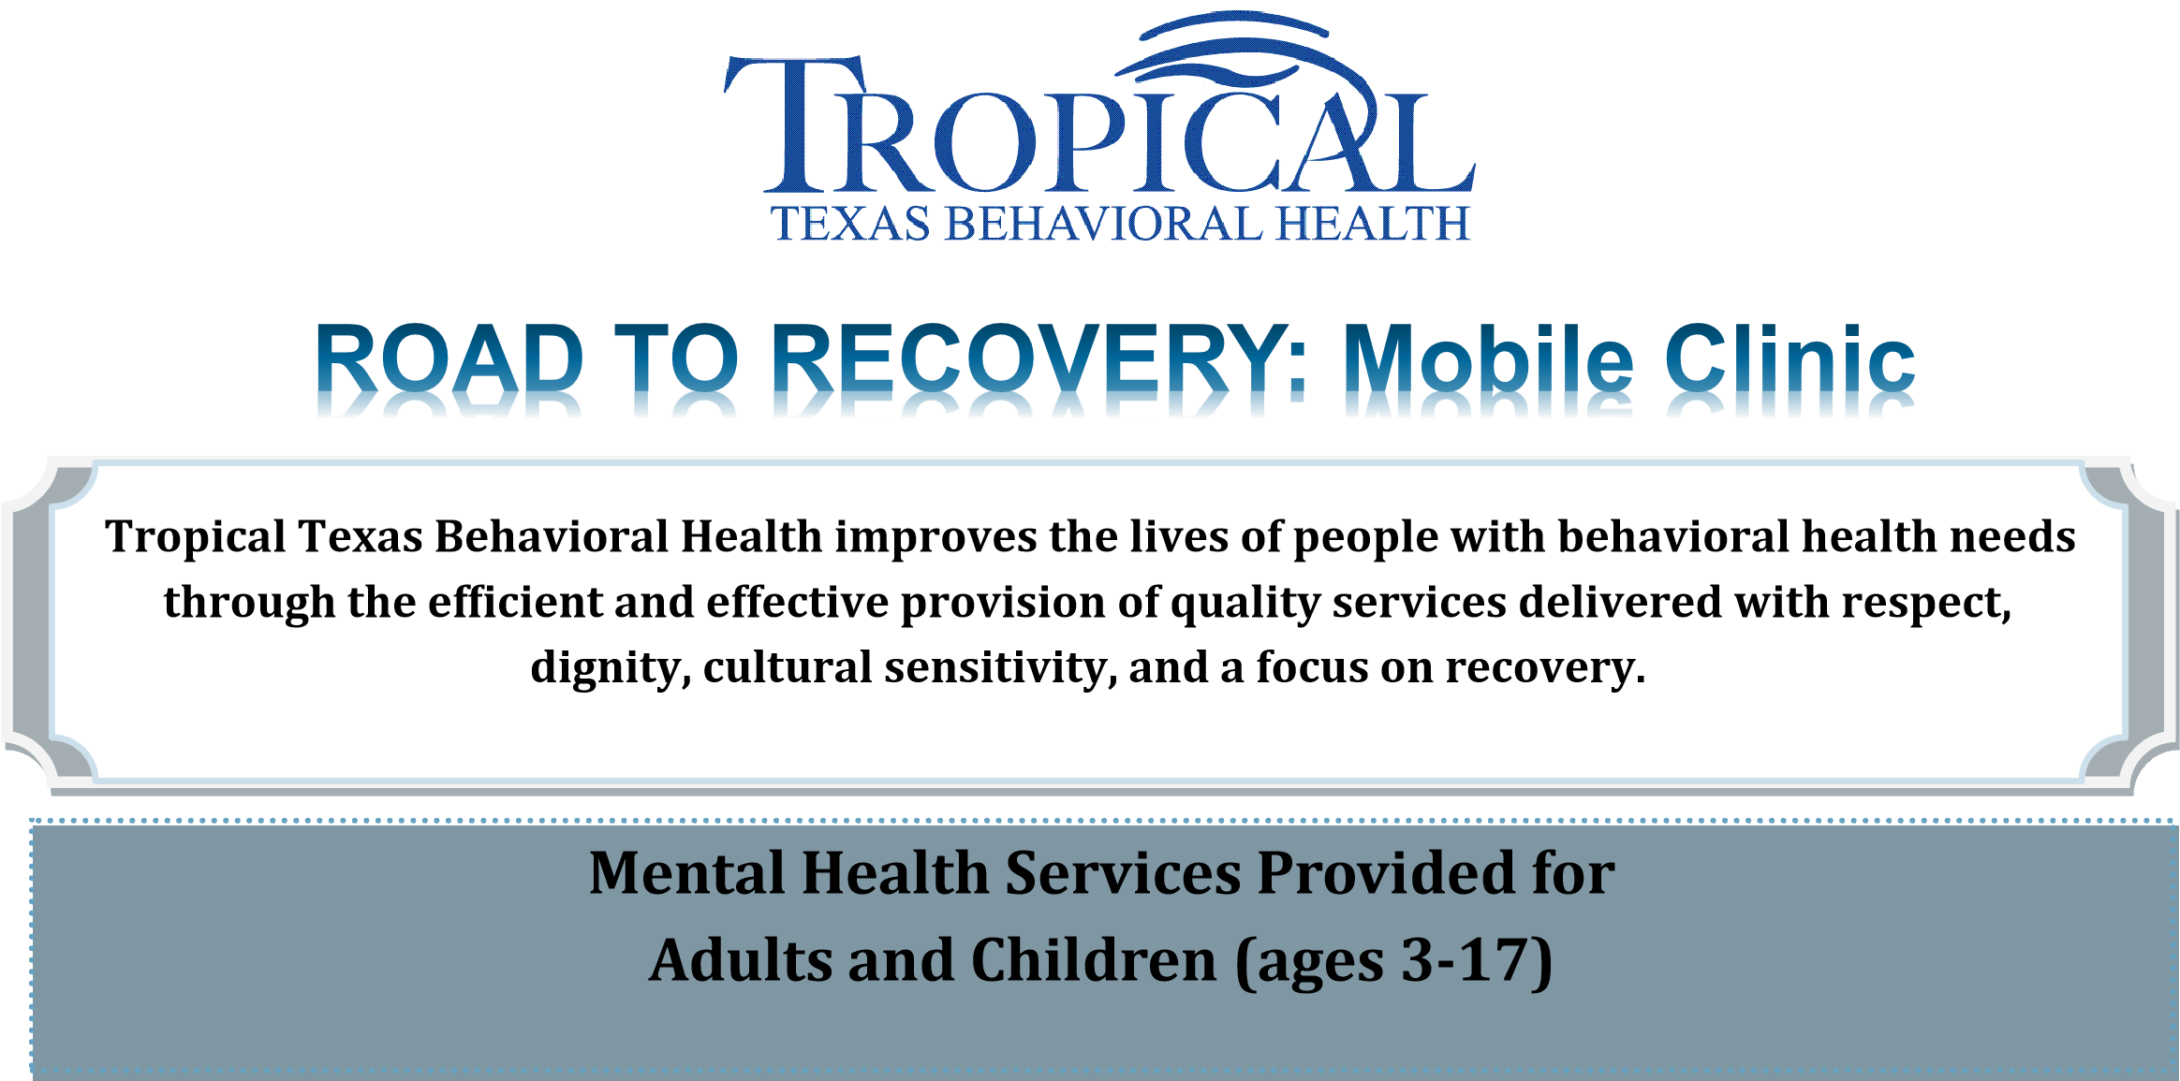
Services included but are not limited to:
- Intake and assessments:
Individuals are administered assessments by clinical staff to determine eligibility and clinical necessity.

- Skills-Training:
The training focuses on daily living and community skills, recreation and leisure, stress management, coping and problem solving skills.

- Case Management:
Case Management help clients and families identify needs, assist in resolving problems and linking clients with other available resources in the community.

- Counseling Services:
Individual counseling services will be provided for individuals who meet criteria.

Tropical Texas Behavioral Health Mobile Clinic will NOT be asking for any legal documentation

Hours of Operation:
Monday: CLOSED
Tuesday – Friday: 10:00AM – 6:00PM
Saturday: 9:00AM – 11:00AM

Hidalgo County:
Main #: (956) 478-2491
Crisis Hotline #: 1-877-289-7199
Mariel Monjaras: mmonjaras@ttbh.org

Cameron County:
Main #: (956) 478-2492
Crisis Hotline #: 1-877-289-7199
Jorge Reyna: jreyna@ttbh.org



Calendar on reverse *Hidalgo County*

.
Tropical Texas Behavioral Health
Mobile Clinic
MonthStart MonthStart

Tue. | Wed. | Thu. | Fri. | Sat.
 |  |  | 1 EOP | 5 San Juan
 |  |  | No Mobile Services | Location based by apt.
5 Alton | 6 McAllen | 7 McAllen | 8 San Juan | 9 Wellness Walk
Alton Recreation Center  349 W. Dawes St. Alton, TX 78573 | Thigpen – Zavala Elementary  2500 Galveston Ave. McAllen, TX 78507 | Hope Family Health Center  2332 Jordan Ave. McAllen, TX 78503 | LUPE  1601 U.S. 83 Business  San Juan, TX 78589 | Fireman’s Park Pavilion  201 N First Lane  McAllen, Tx. 78501
12 EOP | 13 EOP | 14 McAllen | 15 Alamo | 16 San Carlos
No Mobile Services | No Mobile Services | Christa McAuliffe Elementary  3000 W Daffodil Ave McAllen, TX 78501 | Alamo Community Resource Center  1423 S. Tower Rd. Alamo, TX 78516 | Location based by apt.
19 Penitas | 20 Hidalgo | 21 McAllen | 22 EOP | 23 San Juan
Proyecto Desarrollo Humano  17617 Sabal Palm Dr. Penitas TX, 78576 | City of Hidalgo Behind WIC  704 E. Texano Dr. Hidalgo, TX 78557 | Hope Family Health Center  2332 Jordan Ave. McAllen, TX 78503 | Team Meeting | Location based by apt.
26 Alton | 27 McAllen | 28 McAllen | 29 San Juan | 30 San Carlos
Alton Recreation Center  349 W. Dawes St. Alton, TX 78573 | Thigpen – Zavala Elementary  2500 Galveston Ave. McAllen, TX 78507 | Christa McAuliffe Elementary  3000 W Daffodil Ave McAllen, TX 78501 | LUPE  1601 U.S. 83 Business  San Juan, TX 78589 | Location based by apt.

Notes | - Mobile Unit Hours:  Tuesday – Friday: 10:00AM – 6:00PM  Saturday: 9:00AM – 11:00AM  - If you are experiencing a crisis please call the Crisis Hotline at 1-877-289-7199  - Locations are subject to change for questions/information contact Mariel Monjaras at (956) 478-2491  - Si usted esta en crisis, favor de llamar a nuestra Linea de Crisis al 1-877-289-7199  - Nuestra ubicacion podra cambiar para preguntas/informacion llame al (956) 478-2491  pida hablar con Mariel Monjaras

